**PBI Final Project**

1. Data Preparation and Cleaning (10 Marks)

● Extract and transform data in Power Query.

● Clean data: remove duplicates, handle missing values, and format columns.

● Deliverables: Screenshot of Power Query Editor showing cleaned data.

Ans)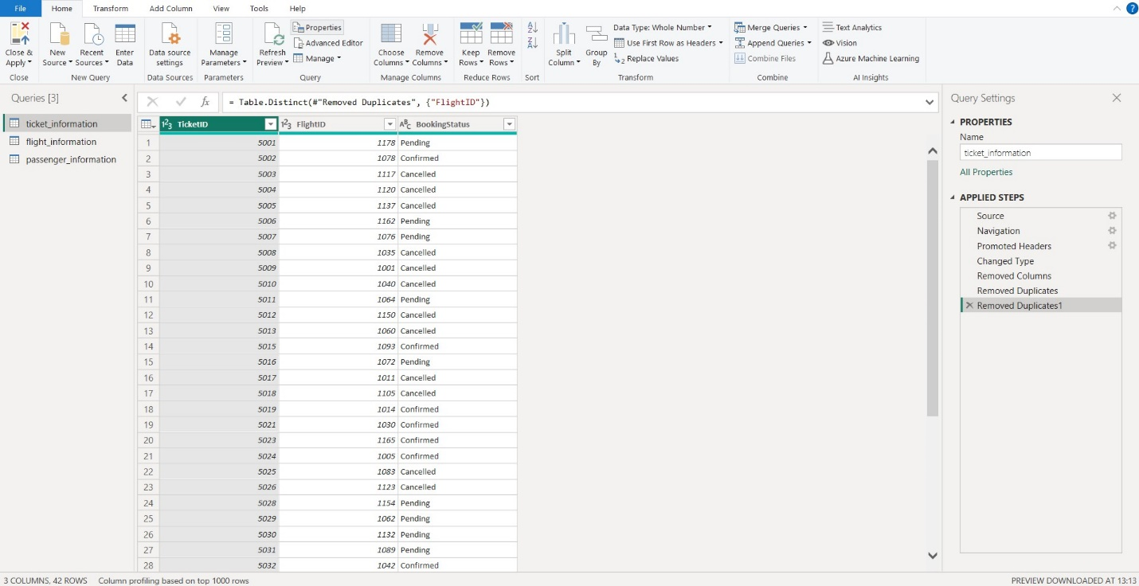

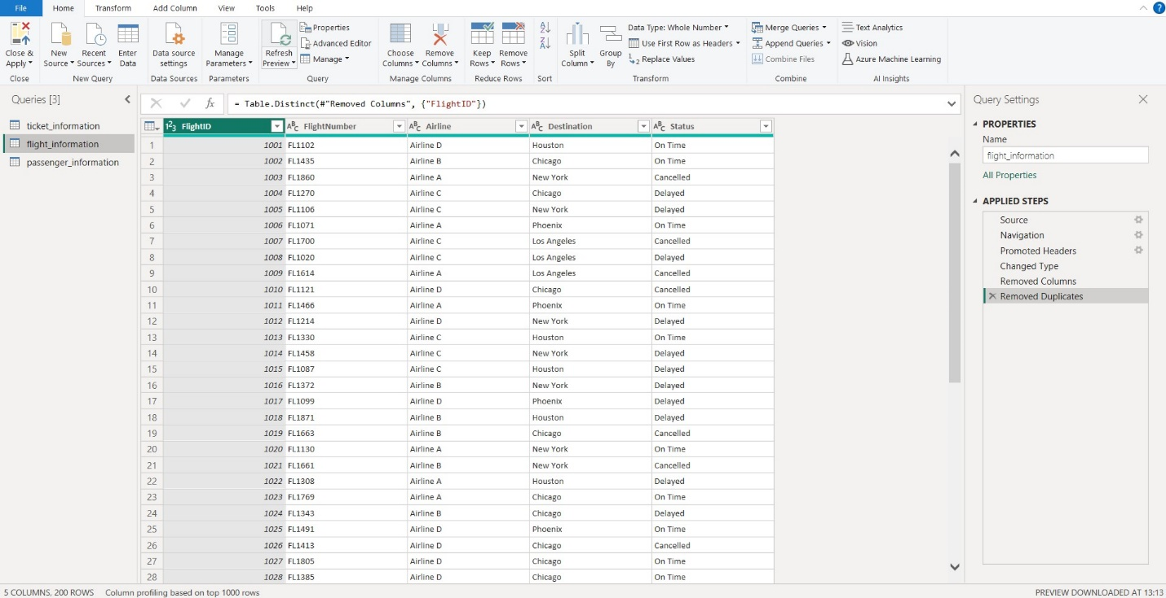

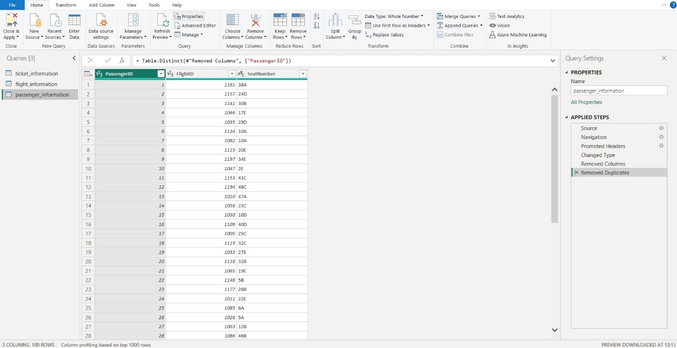

* I have checked the data type for all the columns to be appropriate and removed the duplicates from the primary key columns in each table.

Then, finally **Close and Apply** changes.

2. Data Modeling (10 Marks)

● Create relationships between datasets (FlightID as the key).

● Understand cardinality and configure the model appropriately.

● Deliverables: Screenshot of the data model with relationships

Ans)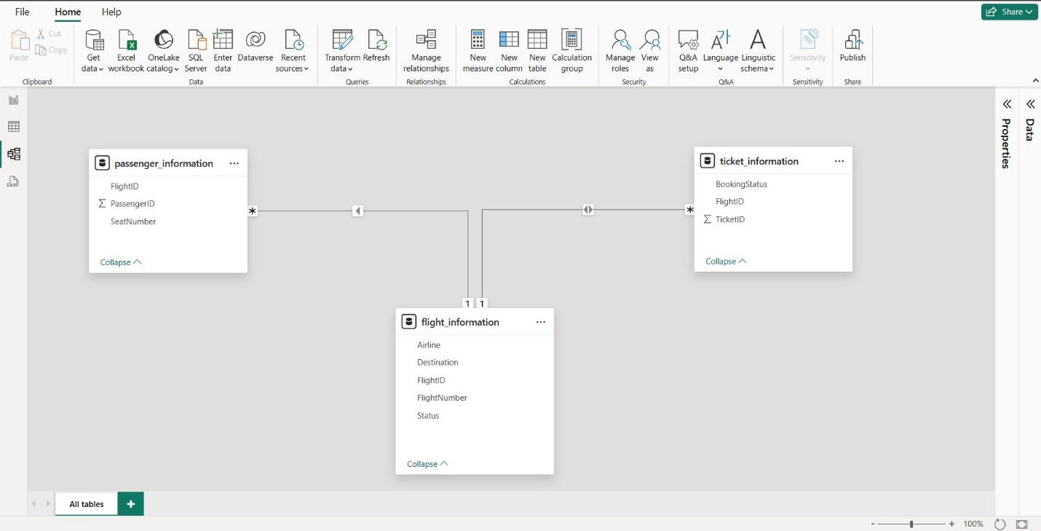

* I have created 1 to many relationship between Flight_information and ticket_information since 1 flight can have multiple tickets.
* Then, I created 1 to many relationship between Flight_information and passenger_information since 1 flight can have multiple passengers.

3. Enhanced Data Insights (10 Marks)

● Add a conditional column to classify flights as "Best" or "To Be Improved" based on status.

Ans) We have three options under the Status column in this table(flight_information): **On Time, Delayed, and Cancelled**.

So, **Best will be for On Time flights** and **To Be Improved will be for Delayed and Cancelled flights**.

Accordingly, I have set the conditions in the conditional column.

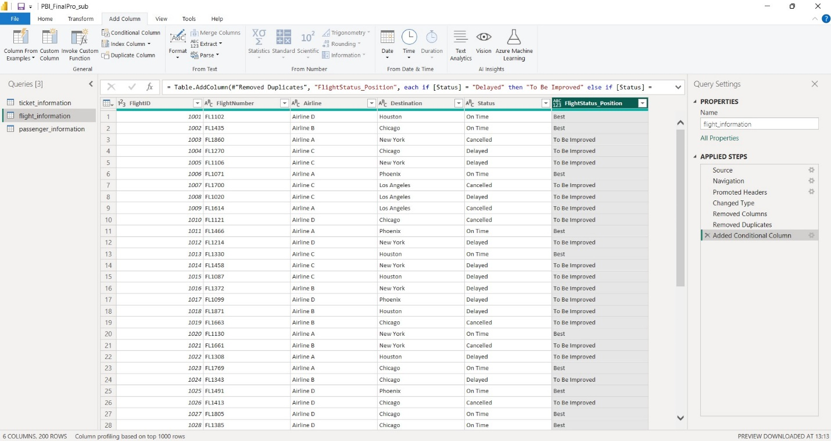

● Use"Column from Examples" to extract the flight number from FlightNumber.

Ans) PFA below.

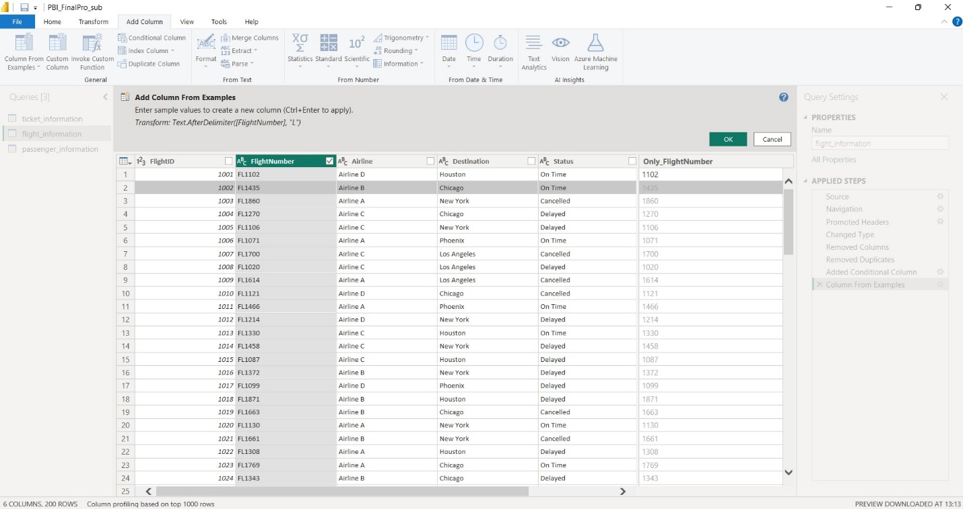

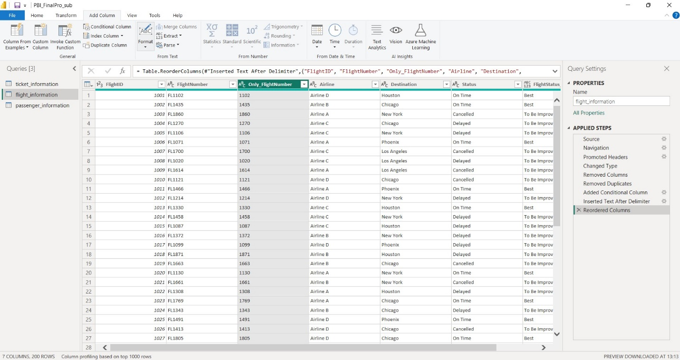

4. Calculations Using DAX (10 Marks)

● Calculate:

○ Total passengers for a specific flight

Ans) TotalPassengers_PerFlight =

CALCULATE(

COUNT(passenger_information[PassengerID]),

ALLEXCEPT(passenger_information, passenger_information[FlightID])

)

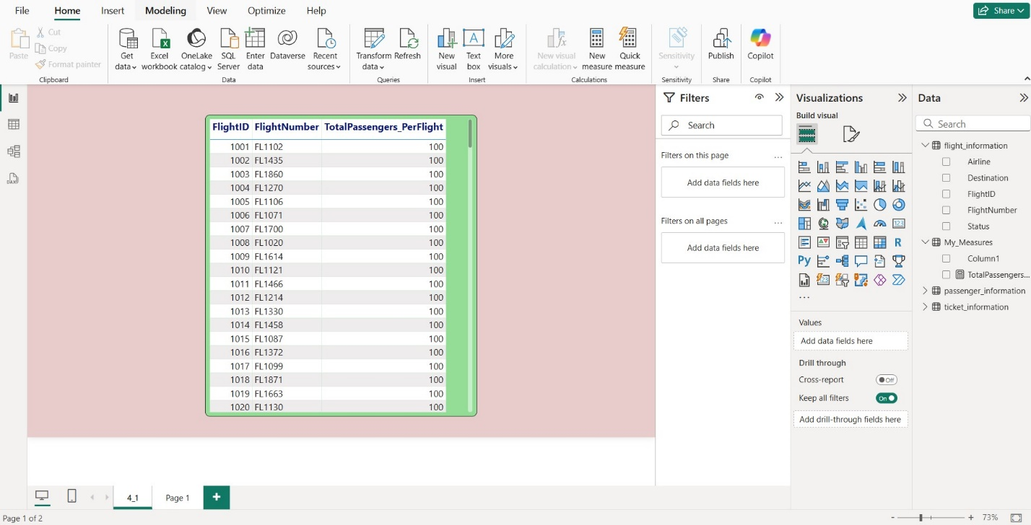

○ Total tickets booked.

Ans) Total_TicketsBooked = COUNT(ticket_information[TicketID])

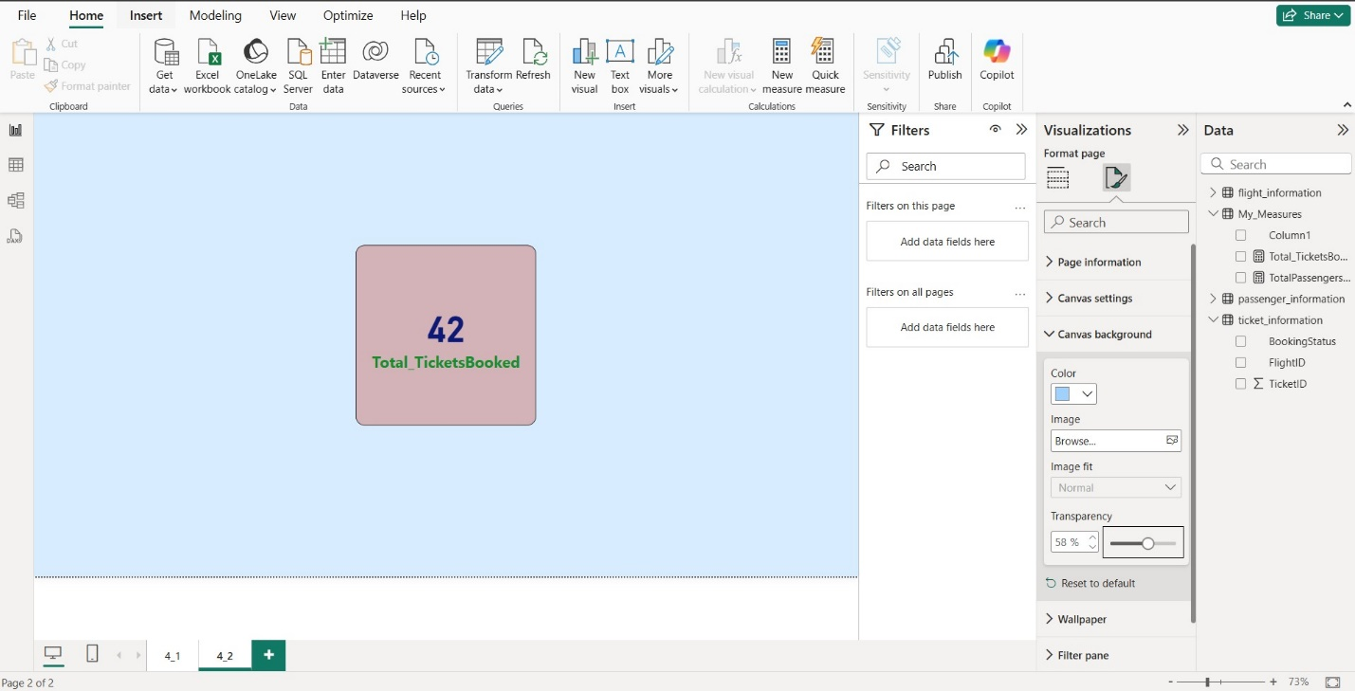

* I have used a single row card since the value was just one.

○ Filtered table showing "Best" flights only.

Ans) Total_BestFlights =

CALCULATE(

    COUNTROWS(flight_information),

    flight_information[Status_Result] = "Best"

)

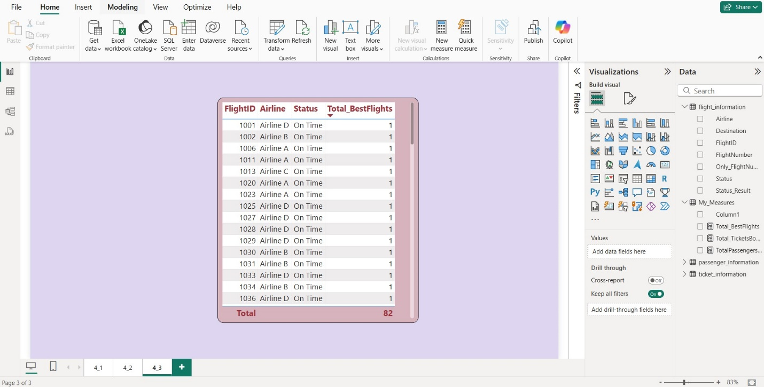

* In my measure, I have used the calculated column that was supposed to be created for 3_1 and then shown the results in the table format as this looked most suitable and neat to understand.

5. Visualization and Interactive Features (20 Marks)

● Create visuals for:

○ Passenger count by airline.

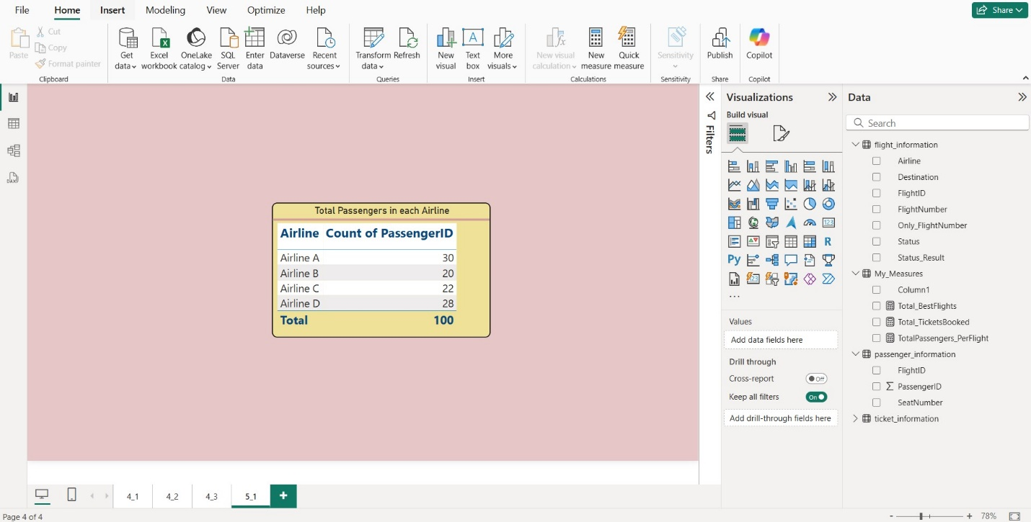

○ Ticket booking statuses.

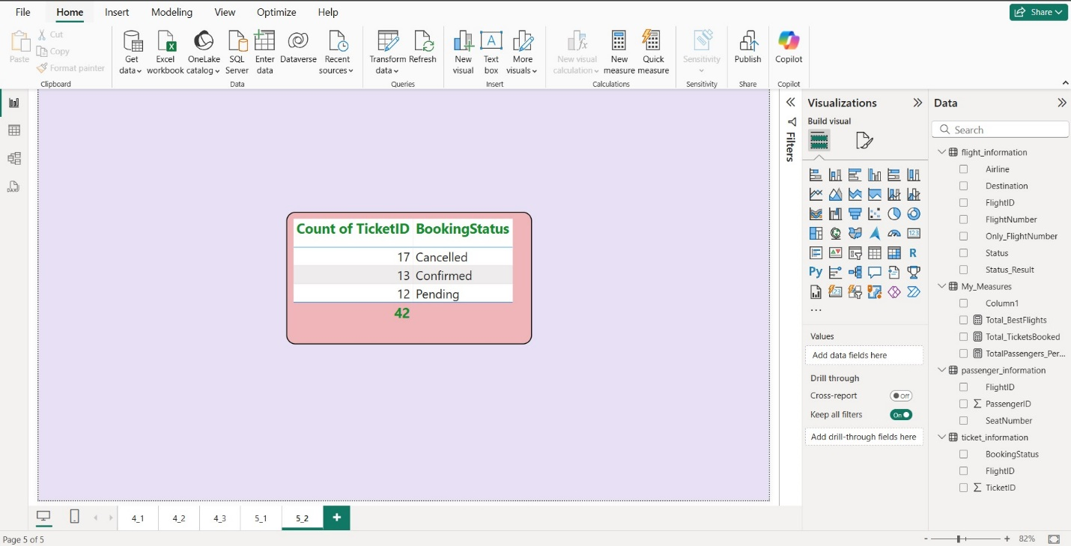

○ Flights by airline and destination.

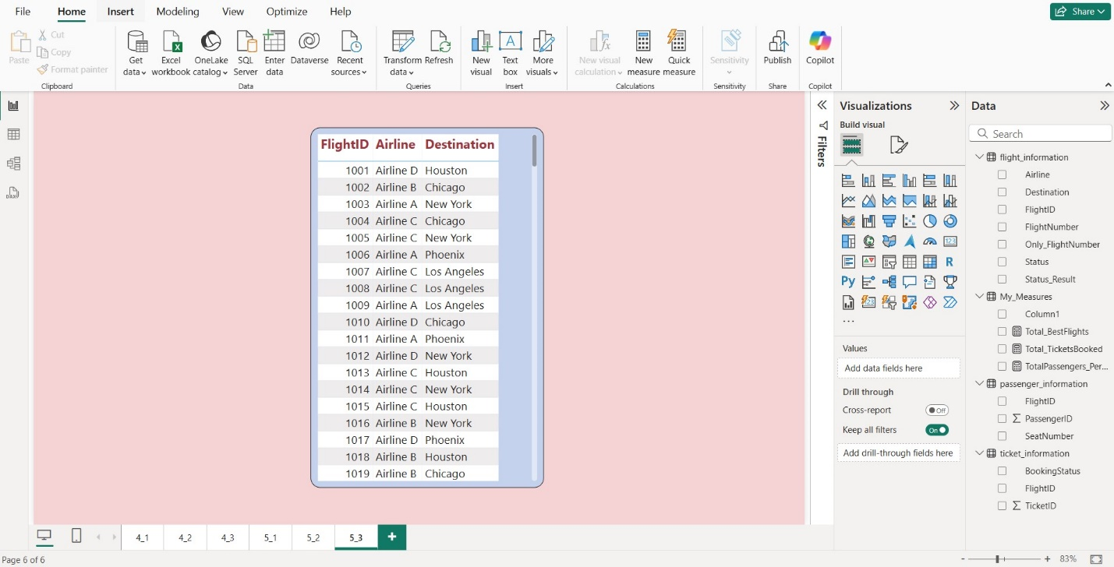

● Add interactive features for:

○ Destination and Airline.

Ans) I have used 2 different slicers and a table visual for this.

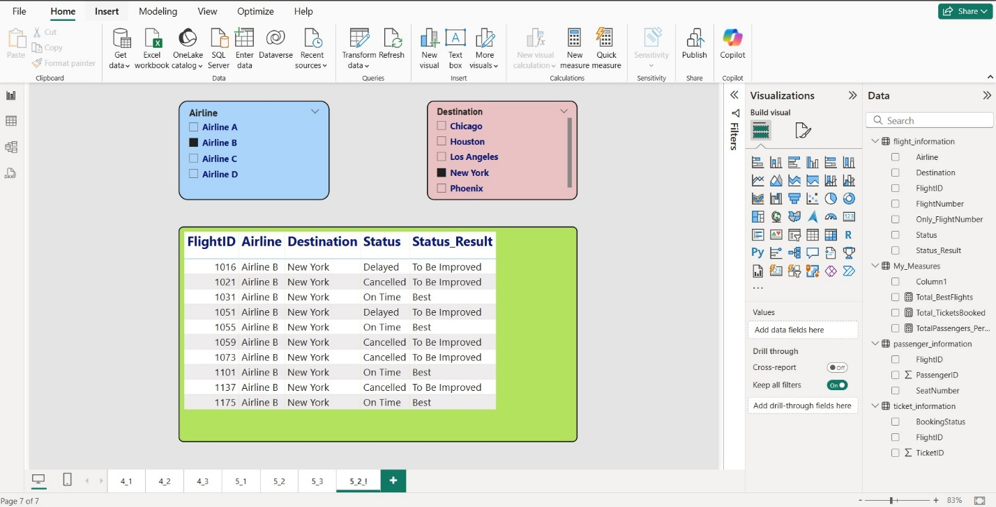

○ Quick views.

Ans)

* I have used Drill Through.
* In this I have used 2 field values – FightID and Destination.
* Now, on any page when I right click on any FightID or Destination, I get to see the option of Drill Through and I select my page 5_2_2 and there it shows the specific and corresponding details only.

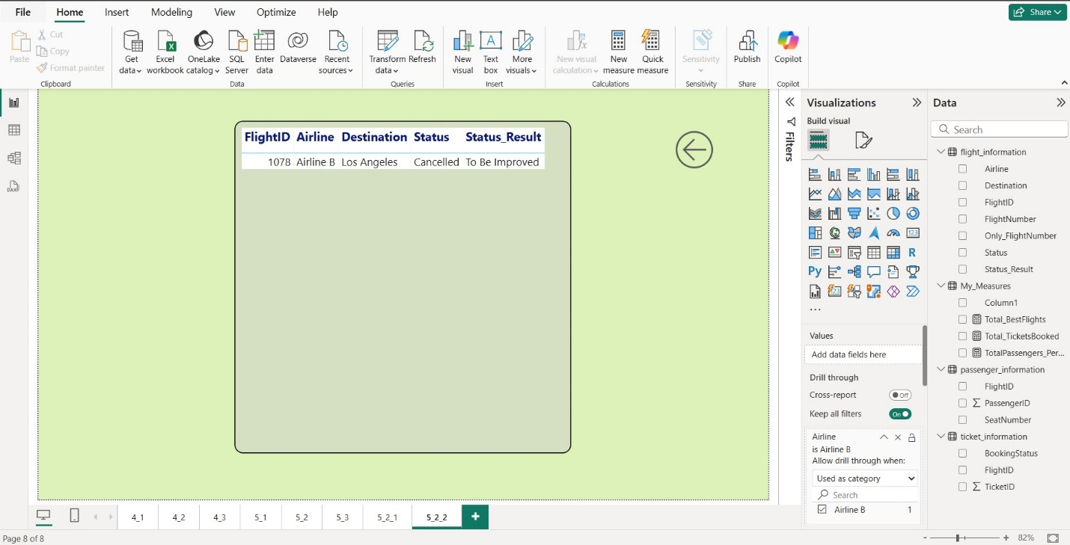

○ Airline-specific pages.

Ans) I have used **Book Mark in one of the page(5_3(part2))** and then **Sync Slicers here to sync multiple pages (5_2_1, 5_3(part1), 5_3(part2), and 5_3(part3))** based on selection of destination on any page.

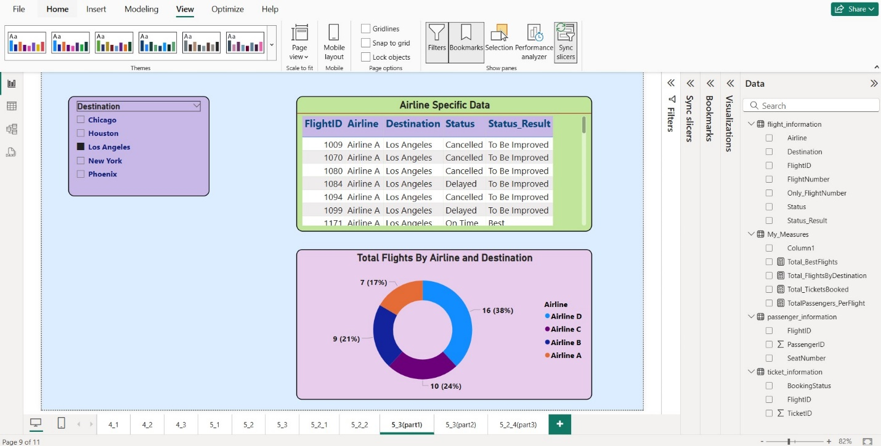

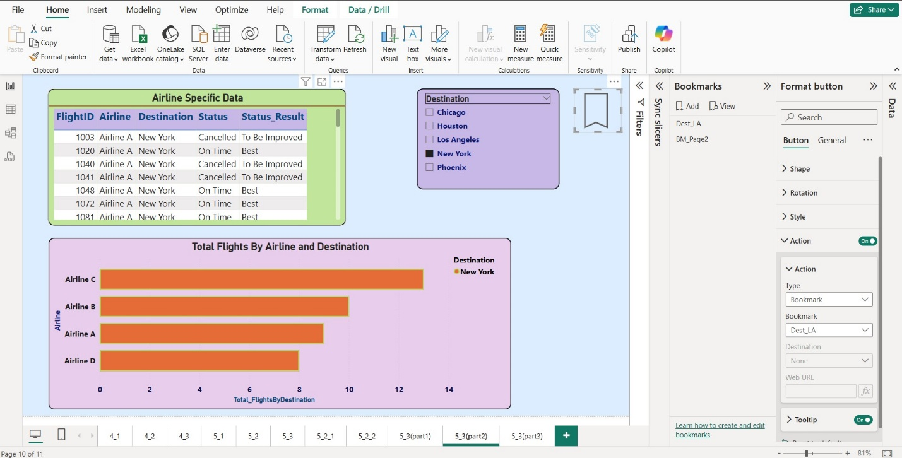

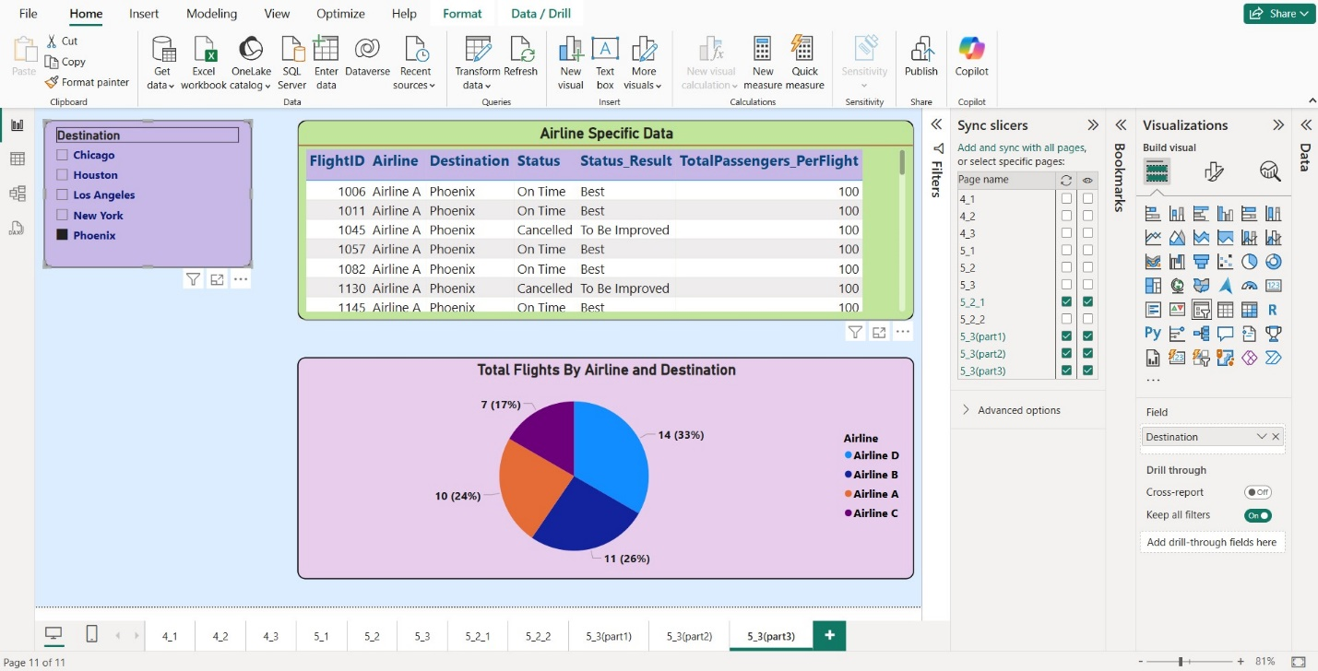

6. Final Dashboard and Power BI Service (20 Marks)

● Design a comprehensive dashboard with key visuals and insights.

Ans) I have made a cool page for this. PFA below.

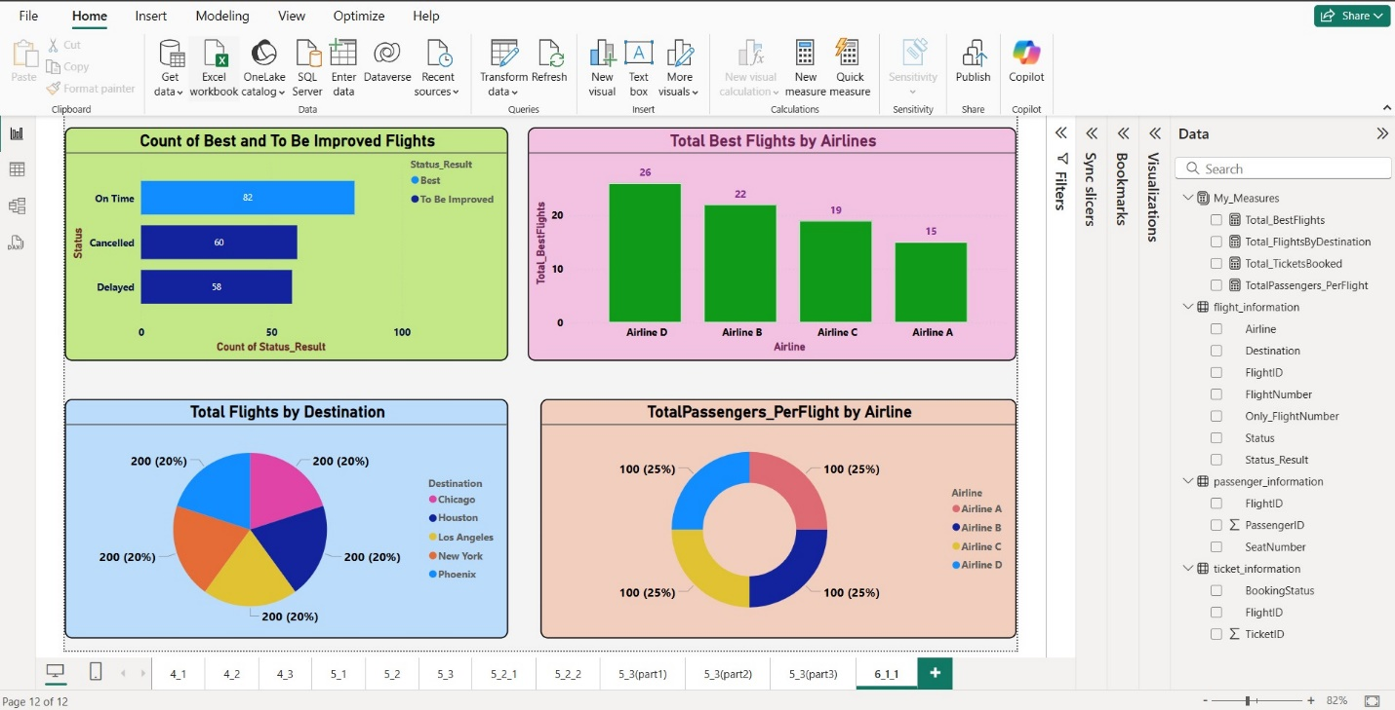

* I tried to showcase the most important key insights in this and less use the other aspects which I’ve already used in the previous solutions.

● Configure Row-Level Security (RLS) for Airline A data and assign it to a user.

Ans) I have attached a screenshot for each step.

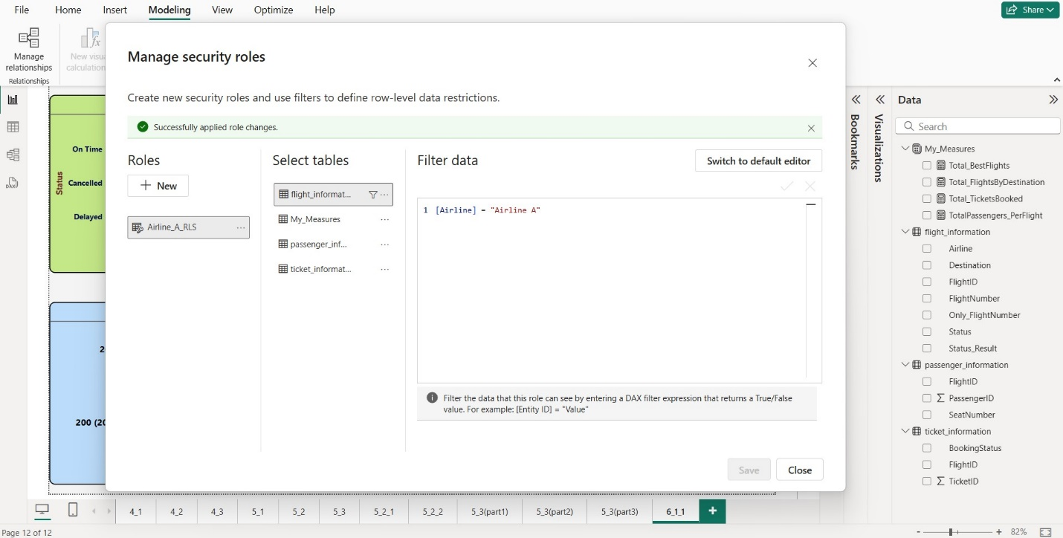

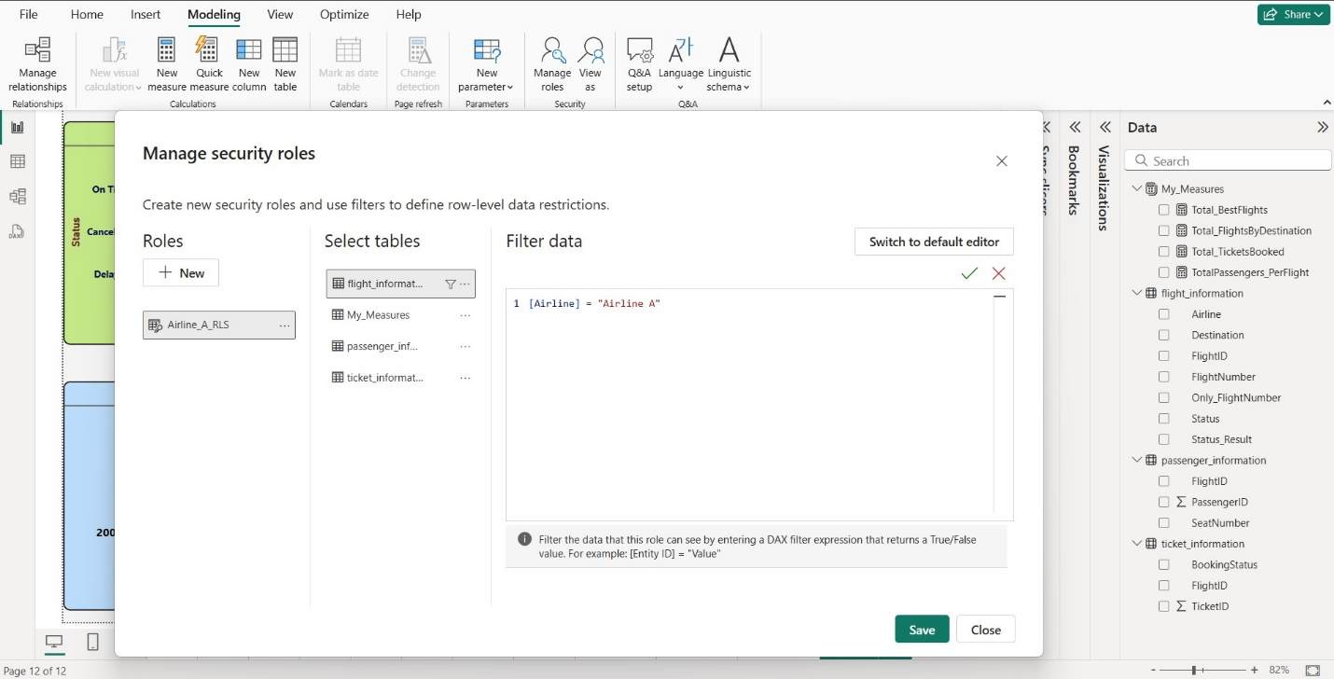

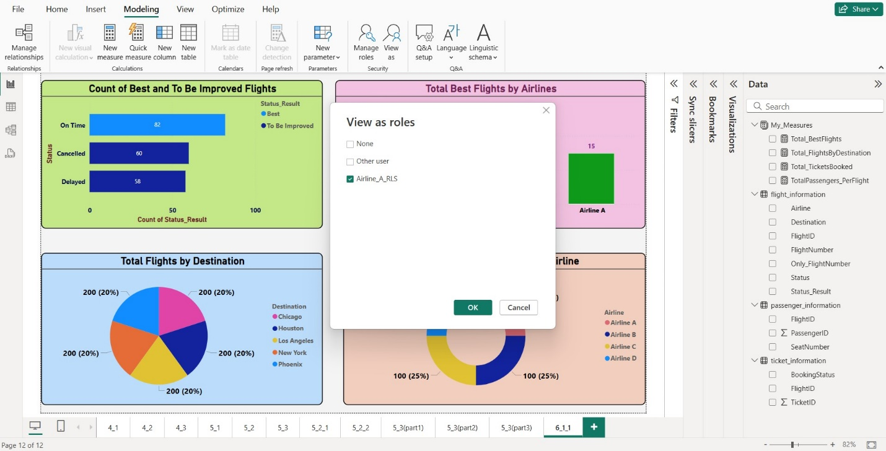

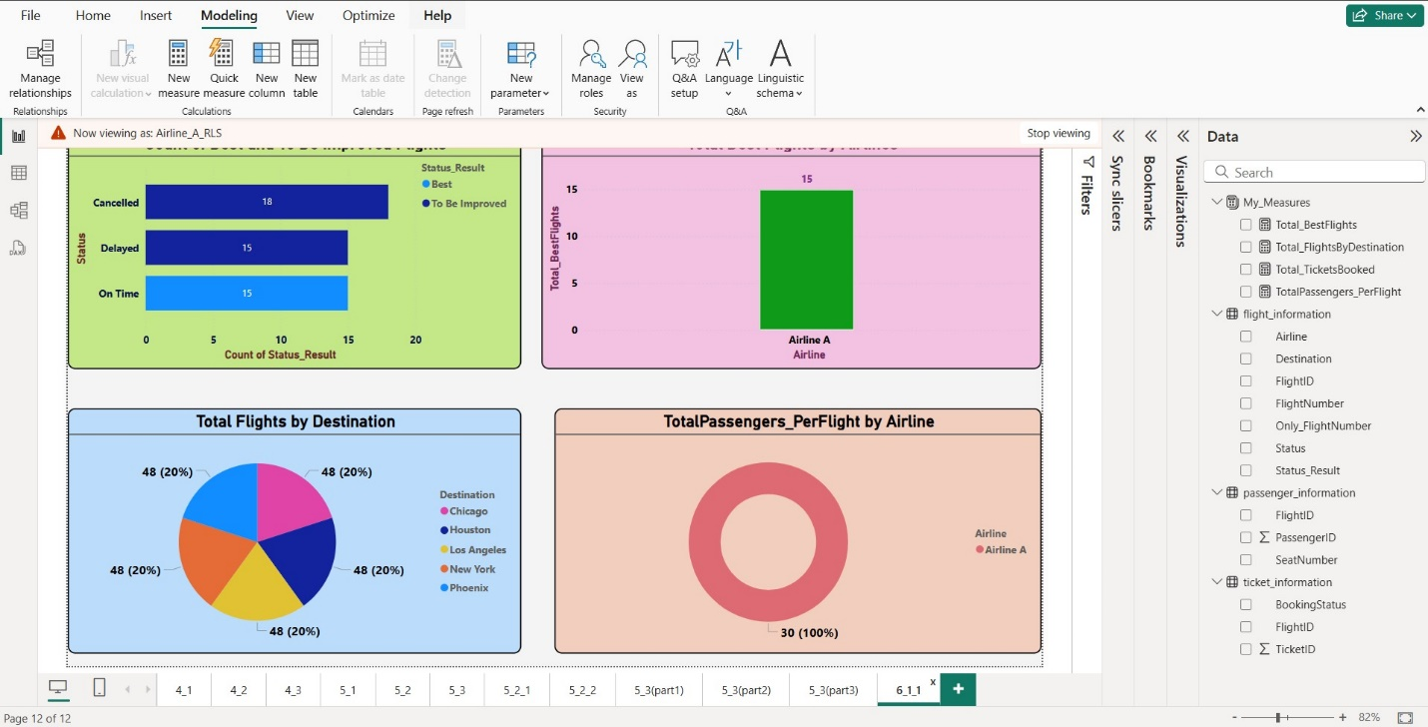

The same reflects on all the individua report pages of this report.

● Set up a schedule refresh at 5 PM daily

Ans) I had to first set up Gateway and then schedule the refresh.

I’ve done it correctly. PFAs.

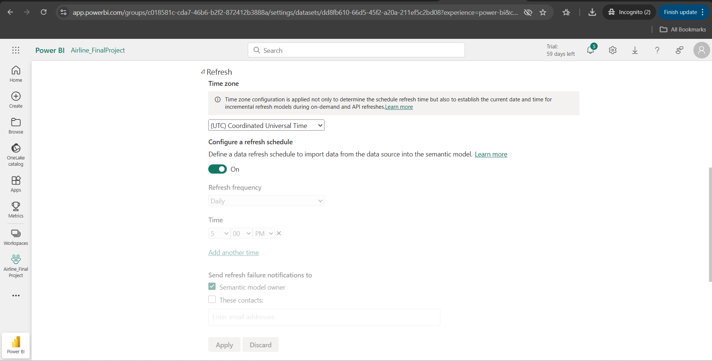

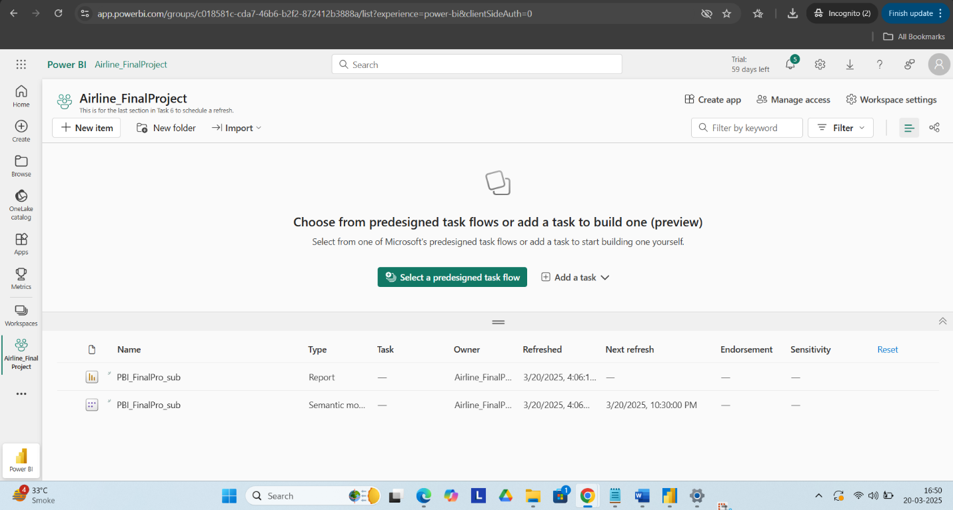

Video Submission (20 Marks)

● Content: 3-5 minute video explaining:

○ Introduction to the project.

○ Problem statement.

○ Key findings and insights

Ans) Here is the link for the video task-

<https://drive.google.com/file/d/1wr-q8AC8xf31jFp3fifljt5KGaw18b3I/view?usp=sharing>

Sorry for my bad throat. I am keeping quite unwell since a few days because of cough and fever.

I hope my solutions will be easy and comfortable for the examiner to see and understand at a glance.

Please inform me if you feel anything is missing from my end.

I’ll be glad to assist.

From my end I feel there’s nothing.

**Thank You!**